Dear parents,
Nessy is now available for your child to access at home.
The login details are as follows:
You will need ‘Google Chrome’ on your device- ipad / tablet or laptop.
- Type ‘Nessy login uk’ in to the search bar
- Go to ‘login to play and learn -Nessy’ the following screen will appear
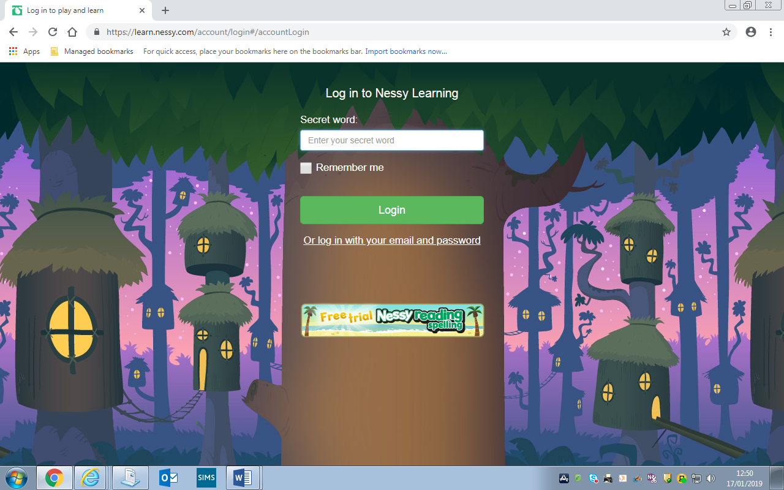
- Type in the secret word ‘loyalhook’ and click login
- Type in your real name which is child’s first name and surname
- The child’s monkey should appear below it and click on their monkey
- The following will appear - click on Nessy reading and spelling
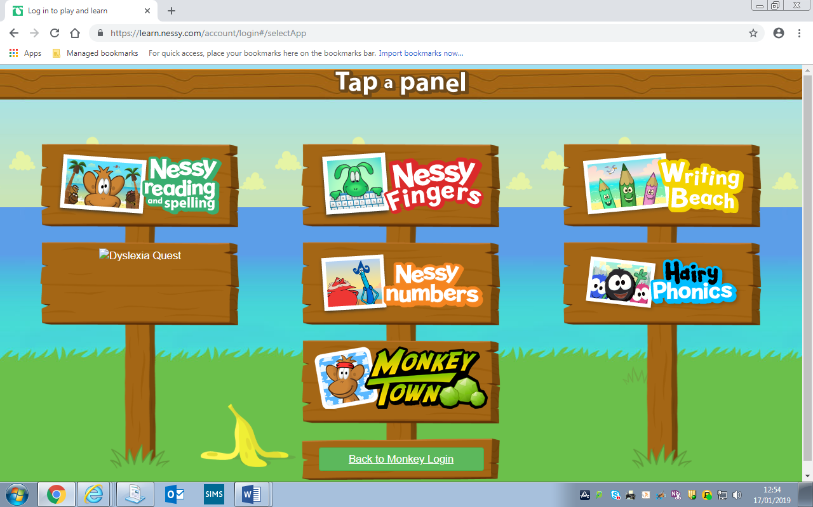

Your child will then be asked to take a reading challenge which will set targets on completion. Do not help your child at all through this assessment this is so important to assess their reading ability.
Your child will also be asked when they log in again to complete another challenge
- a spelling challenge to assess their spelling ability. Do not help your child at all through this assessment.
Your child has access to the ‘Writing Beach’ part of the program also which is excellent for punctuation within writing etc.
Your child is now able to work through the program. It is advised that your child should spend no more than 15/20 mins per session three/four times a week.
Mrs McCloy

