

Prospectus

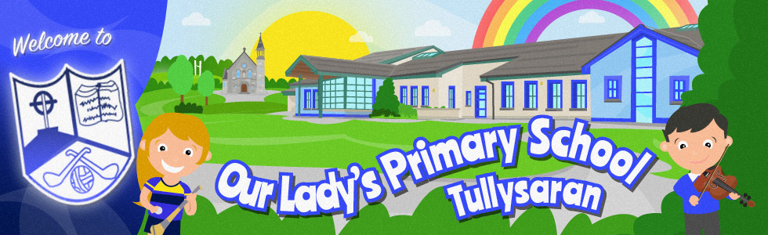

‘Learning through Friendship’

Our Lady’s Primary School,
12, Milltown Road,
Milltown, Benburb,
Dungannon,
BT71 7NJ

Telephone: 028 37548237
E mail: info@ourladys.tullysaran.ni.sch.uk
Website: www.ourladyspstullysaran.com

Dear Parent/Guardian,

Thank you for considering Our Lady’s Primary School as the next step on your child’s journey! We sincerely hope that you will experience a warm welcome from our staff and pupils and feel a connection with our vision and mission statement based upon the values of Friendship, Community and Faith to help every child achieve their potential.

Our School is a Catholic Maintained Co-educational Primary School catering for pupils from age 4 to 11. There are currently 182 pupils enrolled in seven mixed ability classes from Reception/Primary 1 to Primary 7. We have state of the art resources and a very committed staff, who want the very best for your child at every step along the way.

I hope this prospectus gives you an introduction to our school and community. If you require any more information, please do not hesitate to contact us.

I look forward to meeting you and your child and hope it will be the beginning of many happy years of working together.

Yours Sincerely,

Justin Toner

Justin Toner
Principal

Contents

Sections | Page(s)
Background to our School | 3
Board of Governors and Staff | 4 & 5
Application and Admission | 6
Ethos Statement | 7
Curriculum | 8
The School Day | 9
Meal Arrangements / Uniform | 10
Home School Partnership | 11
Parental Meetings / Progress Reports | 12
Pastoral Care & Positive Behaviour | 13
Children with Additional and Special Educational Needs | 14
Holidays | 15
Pupil Attendance | 16
Religious Education | 16
Equal Opportunities | 17
Homework | 18
Extra-Curricular Activities | 18
Eco Schools | 18
Breakfast, 123 & 3-5 Clubs | 18
Charging and Remissions Policy | 19
Drugs Education | 19
Links with the Community | 19
Handling Complaints Procedure | 20
Data Protection | 21
Mid-Academic Year Changes | 21
2025/26 Classes: P1 – P4 | 22
2025/26 Classes: P5 – P7 | 23
School Contact Details | 24

Background to our School
Our Lady’s Primary School, Tullysaran was formed following the amalgamation of Tullysaran and Tullymore primary schools in 1997. We have seven well-resourced classrooms with interactive white boards, an indoor resource area, large multi-purpose hall and extensive outdoor grounds with full access to a play park. The school delivers a broad and balanced educational experience in line with the requirements of the Northern Ireland Curriculum.

In school we place a great emphasis on pastoral care. We strive to ensure all our pupils feel safe, secure and happy so that they can achieve their full potential.

As a Catholic school we pride ourselves in our Catholic ethos which is evident throughout the school. Confirmation and First Communion are special community celebrations.

We offer a breakfast club from 8am in the morning and afterschool supervision for all P1-P7 pupils until 2-5pm. We have a wide variety of extra-curricular activities on offer including: Sports club, Art, Drama, Lego Club, Lego Spike, Dance, Fiddle, ICT Club, Soccer, Camogie and Gaelic football. We also provide extra lessons for children in Primary 6 and 7 who are preparing for external examinations.

It is the policy of the school to make parents feel welcome, so don’t hesitate to contact the school if you have any queries.

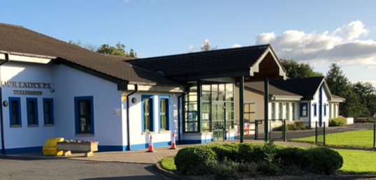

Board of Governors and Staff

Board of Governors: -
Chairperson/Trustee – Mr Kevin Curran
Vice-Chairperson/Trustee – Mr Ciaran McCartan
Parish Trustee – Mr Pat Mallon
Parent Trustee – Mr Colm Mc Gahan
EANI – Mr Daniel Copley
EANI – Mrs Ellen Walsh
DENI – Mrs Patricia Donnelly
Parent Governor – Mrs Lynette Donnelly
Staff Governor – Ms Noreen Loughran

Teaching Staff: -
P1 & Numeracy/WAU Co-ordinator – Ms Noreen Loughran
P2 – Mrs Kerry Dillon
P3/4 & ARTS Co-ordinator – Miss Catherine Holland
P3/4 & ICT Co-ordinator – Mrs Aideen Mc Cloy
P5 & Deputy Designated Teacher – (Mon-Thur) Mrs Karina O’Hara
P5 Teacher on Fridays - Miss Megan Gorman
P6 – Miss Kathleen Rafferty
P7 & Literacy & Well Being Co-ordinator – Mr Ryan McCusker
Principal & SENCo – Mr Justin Toner

Board of Governors and Staff

Teaching Assistants: -
P1 – Mrs Danielle Murray & Mrs Aine Daly
P2 - Miss Aimee Duffy & Miss Jessica Curran
P3/4 – Mrs Louise Cahill, Mrs Aisling Rooney, Mrs Irene White
P5 - Mrs Sheila Hughes & Miss Chloe Farley
P6 – Mrs Una King, Mrs Joanne Kearney, Miss Sara McCreesh
P7 – Mrs Mary Fullerton

Breakfast Club Supervisors – Mrs Rosie Morton & Miss Aimee Duffy
123 & 3-5 Club Supervisors – Mrs Louise Cahill, Mrs Irene White, Mrs Sheila Hughes, Mrs Danielle Murray, Miss Jessica Curran & Miss Sara McCreesh

School Secretary – Mrs Berni Mc Anallen

Ancillary Staff
Caretaker - Mrs Rosie Morton
Assistant Caretakers – Miss Shannon Hughes

Kitchen Unit Supervisor – Mrs Briege Mackle
Catering Assistants – Ms Kerry Creaney & Mrs Alva McIlvanna

Application and Admission
A copy of Our Lady’s Primary School’s Admissions Criteria is published by the Education Authority and is available on our website and the Education Authority website www.eani.org.uk/parents/admissions/search-admissions-criteria.
Prospective parents are most welcome to visit the school. If they wish to do so, they should phone or email to make an appointment with the Principal.

APPLICATIONS AND ADMISSIONS TO RECEPTION AND PRIMARY 1
Year | Total Reception Applications | Total Reception Admissions | Total Primary 1 Applications | Total Primary 1 Admissions
2023/2024 | 17 | 6 | 19 | 19
2024/2025 | 16 | 0 | 23 | 23
2025/2026 | 4 | 4 | 21 | 21

Entrants to Reception or Primary 1
New parents/guardians and their children will have an opportunity to spend ‘a getting to know you’ session with their teacher in Reception/P1 and meet the Principal who will inform them of the September arrangements for starting school. They will also be provided with welcome information to share at home. This should happen in June with children’s induction sessions occurring in August or September. A Curriculum information session for all parent(s)/guardian(s) of P1 children will be held in September or October.

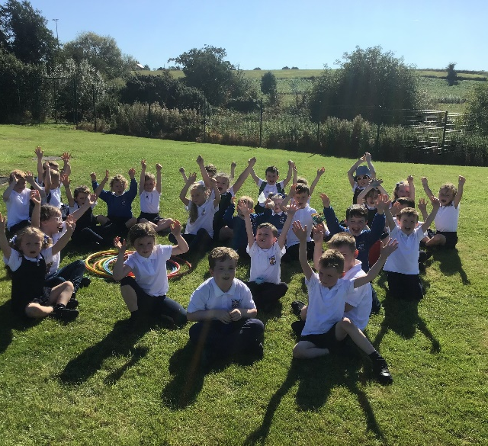

New Parents/Guardians P2 – P7
You will be invited to meet the Principal and be given an opportunity to view the school premises. You may also meet your child’s prospective teacher.

Ethos Statement
Our Lady’s Primary school is a focal point for the community. We want our school to be a caring environment which effectively develops the academic, personal, social and spiritual potential of each child.
We are a Catholic School and as such we have a distinct ethos, but we welcome children from all faiths and none.
Catholic Education takes place in communities inspired by the Spirit of Christ. Christ’s commandment to love God and neighbour inspires a caring ethos which is expressed in relationships within and beyond Catholic Schools.
The education in our school is person centred. It promotes the dignity, self-esteem and full development of each person who is made in God’s image and uniquely loved by God.
Catholic Education is inclusive. It is respectful of and engages with people of all beliefs; it encourages the religious development of all in their own faith.
Catholic Education is rooted in the gospel values of Respect for Life, Solidarity, Truth and Justice. It aims to harmonise faith and culture, build a better society and pursue the common good.
Together we aim to provide high quality rounded education for all our children so that they develop their full uniqueness and potential.
In our school the person and message of Christ find expression in:

- Communities of Faith, Service, Prayer and Worship.
- The development of each person’s full potential in a climate of joy, freedom, respect, challenge, co-operation and celebration.
- The enrichment of pupil life -intellectual, physical, spiritual, moral, social and emotional.
- The promotion of a spirit of charity, social justice, global awareness and concern for others leading to practical outreach and partnerships.
- A cultural of tolerance where people of diverse identities are recognised welcomed respected and cherished.
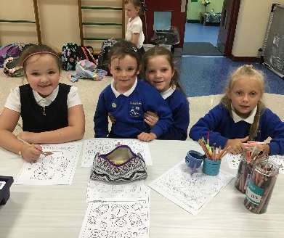
- Listening, mutual understanding, trust, reconciliation, healing and peace.
- The preparation of pupils to lead fulfilling and purposeful lives which will contribute to the common good.
- Celebrating and promoting family and community life.

Curriculum
It is the policy of the Board of Governors of Our Lady’s Primary School that all the pupils will receive their full entitlement under the Northern Ireland Curriculum. The School Development Plan is continually updated to take cognisance of changing needs, DENI policy and other initiatives. It is the tool for self-improvement for the whole school community where everyone has a say with an emphasis on promoting literacy and numeracy.
The curriculum shall be implemented so that the desire to learn will be encouraged in the pupils and that thinking and reasoning will be stimulated. It is important that children learn to independently apply themselves to the work in hand and are ready for transition at every stage.
The acquisition of knowledge and skills and understanding of what has been learned will be regarded as very important. This acquisition will, however, be placed in the context of the development of sound moral values based on the Catholic religion.
All parents will be invited to a curriculum information workshop at the beginning of the academic year. They will receive an overview of the year and additional information may be requested.

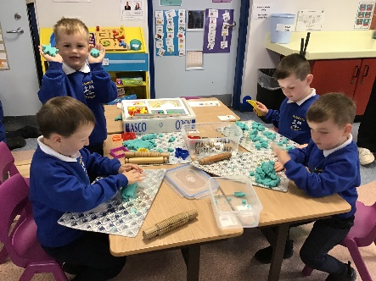
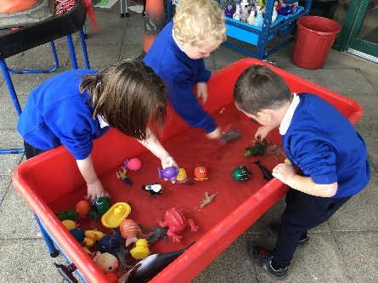

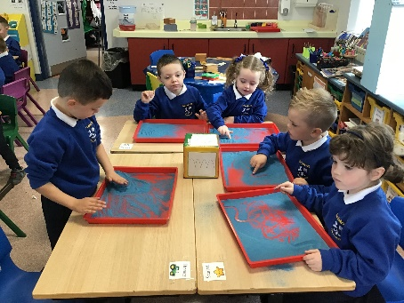

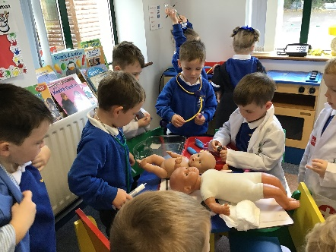
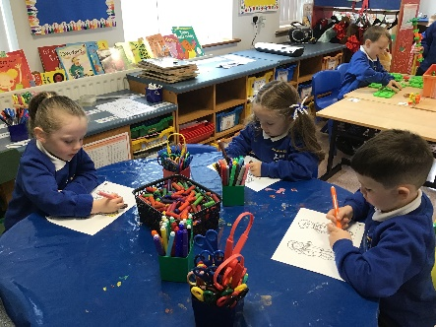

The School Day

The school hours are as follows:

Reception Class | 9.00 am | 1.00 pm (12noon until Halloween)
Primaries 1 to 3 | 9.00 am | 2.00 pm
Primaries 4 to 7 | 9.00 am | 3.00 pm

All children should come to the playground in the morning and line up in class lines when the bell rings at 9.00 am. Children are supervised in the playground from 8.40 am. When the bell rings they will be brought to their class by their class teacher. On wet mornings children should come directly into the school through the designated areas.
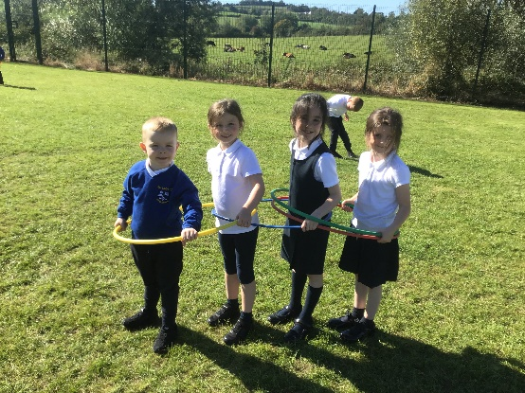

Meal Arrangements
Lunch/Dinner Times
Reception/Primary 1, 2, 3 & 4 | 12 noon to 12.45 pm
Primary 5 – 7 | 12.45 pm to 1.30 pm

Dinner from the school canteen is at a cost determined by EA of £3.10. Applications for assistance with payment of school dinners are available on the Education Authority website. If your child chooses to take lunch you are asked to bear in mind our healthy eating policy and refrain from including fizzy drinks or sweets in children’s lunch boxes. We also have some children who have severe food allergies so please ensure that your child does not bring nuts or seeded bread. Thank you.

Uniform
It is the Board of Governors’ wish that all pupils should wear the school uniform. The uniform gives the children a sense of identity with Our Lady’s Primary School. Applications for assistance with purchases of uniform are available on the Education Authority website. All items of uniform should be clearly marked.

Reception/Primary 1 to 7
Blue sweatshirt with crest
White polo shirt
Navy trousers or tracksuit bottoms (Plain navy – not branded)/Pinafore/Skirt
Plain black footwear

PE
P 3-7 – T-shirt/jersey, shorts or tracksuit bottoms

Summer (Optional)
Blue check dress/plain navy shorts (not branded)

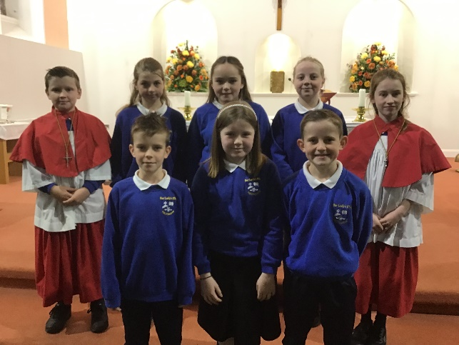
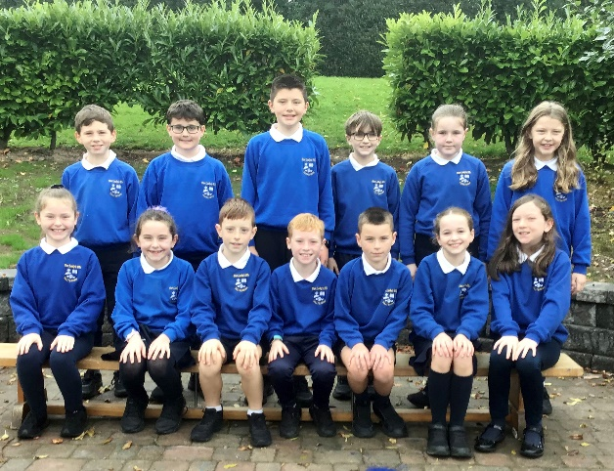

Home School Partnership
Parents can and should help the school by taking an interest in all aspects of their children’s work, by speaking well of the school and the teachers, and encouraging their children to be well behaved. Parents can also help by encouraging punctuality, the obeying of safety rules, ensuring that children wear the school uniform which should be kept neat and tidy and by collecting their children from school at the appointed time.
We ask parents to show interest in their child’s class work and ensure that homework is completed to a good standard. They should be aware of school rules and procedures and encourage their children to abide by them. Parents are expected to attend planned meetings with teachers and support school functions. They should provide the school with all the necessary relevant background information about their children, or any significant change in their medical needs or home circumstances, including telling the school promptly about any concerns.

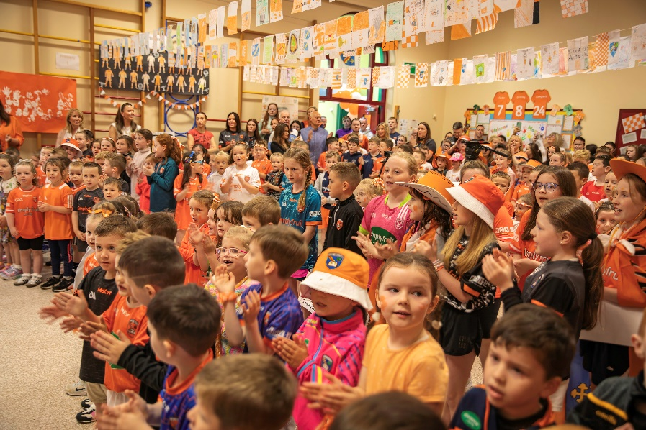

Parental Request for a Meeting
Parents are welcome to discuss their children’s progress at any time. To avoid disruption of classroom work, the following procedures should be followed:

Emergency - Parents/guardians contact the school secretary who will arrange a discussion with the Principal.

Non-Emergency - Parents/guardians should contact the school secretary to arrange a meeting with the class teacher at a mutually convenient time.

Progress Report
Parents will be informed of their children’s progress by:

An annual Parent Teacher meeting during term one and a ‘Keeping in Touch’ (KIT) call in term two when parents will be informed of the school’s opinion of the child’s progress and also of any information given by assessment procedures.

Parents will receive an annual written report, generally in June, on their child’s progress.

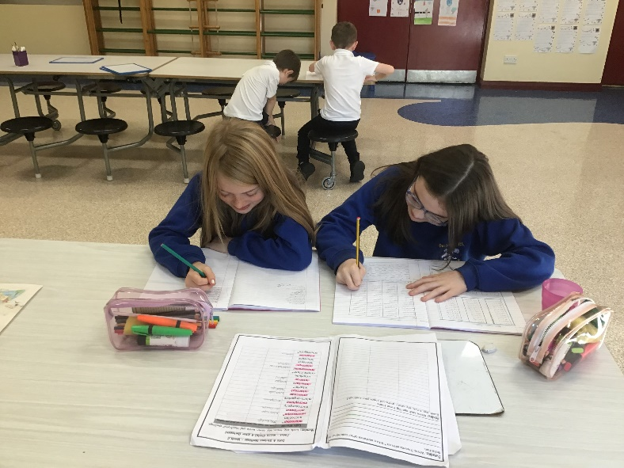

Pastoral Care
In line with the policy of maximising the potential of each pupil, the school recognises that it has a responsibility to do everything possible to care for each child’s physical and emotional well-being. The school will endeavour to provide a comfortable and safe environment for learning.
All teachers and staff in the school have a duty of pastoral care for pupils. A teacher with special responsibility for Pastoral Care/Child Protection has been appointed by the Board of Governors to co-ordinate Pastoral Care and Safeguarding in the school. The school would be grateful to receive any information about any difficult home circumstances which may be causing distress or anxiety. This information will be treated as confidential and relayed to others, with parents’ agreement, on a need-to-know basis.
A Pastoral Care leaflet incorporating Pastoral Care and Child Protection is issued at the start of each year. Detailed copies of our Pastoral Care and Child Protection Policies are available on request.
In all cases it will be the school policy to act in the best interests of the child.

Positive Behaviour
It is part of our policy to emphasise positive approaches to maintain and improve behaviour. This school promotes positive behaviour and attitudes by recognising and rewarding them. Each week children from each class will be selected for Merit awards, which will be formally presented to them during school assembly. Their names, including the reasons why they received the award, will be read out at assembly. As a reward for achieving the Merit Award the class teacher may present other privileges to the child(ren) e.g. to be first in the line during the week.

It is the school policy that behaviour should be based on respect for self, respect for other pupils and respect for adults. In those cases, where a child has transgressed the school rules there is a graded set of sanctions involving various members of staff in order of seniority. In any case involving a serious breach of rules, parents/guardians will be involved either by receiving a written report from school, by telephone or by being invited to come to school to discuss the matter. The school’s Positive Behaviour Policy outlines expectations, rules, rewards, and sanctions.

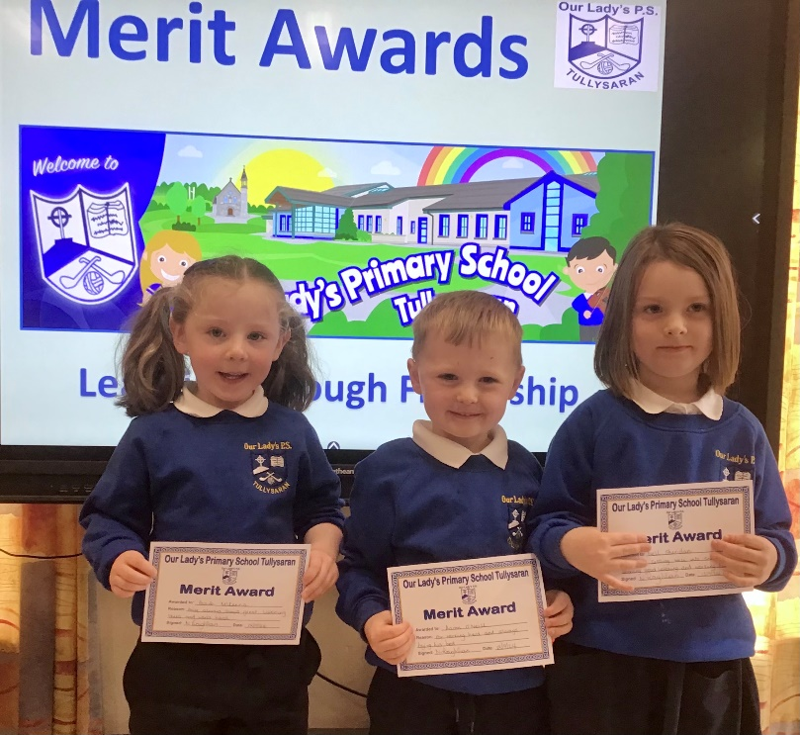

Children with Additional and Special Educational Needs
Some of the children attending the school will have Special Educational Needs. These may arise from the child’s physical need or his/her learning abilities. As it is the intention of the school to maximise the potential of each of the pupils, the school will endeavour, within its resources, to meet these needs.

All the teachers in Our Lady’s Primary School have responsibility for children in their classes who have Special Educational Needs. It is our aim to ensure that the Special Educational Needs of children are identified as early as possible and that the procedures for meeting these needs are effective. We have adopted the Code of Practice and SENDO legislation which has enabled us to effectively meet the Special Educational Needs of most children within the mainstream school with outside specialist help when necessary.

As a result, children with Special Educational Needs are taught the Northern Ireland Curriculum by their class teachers within the normal classroom setting. Class teachers and assistants meet regularly with the Special Needs Coordinator (SENCo) to discuss ways of supporting pupils to overcome learning difficulties and draw up Individual Education Plans (IEPS).

We recognise the invaluable contribution that can be made by parents/guardians to assist their child’s progress and it is our policy to keep them informed and to invite them to work in partnership with the school at every stage.

Our SENCo co-ordinates Special Need’s Provision and organises withdrawal sessions as relevant. It may be necessary to refer a child to Educational Psychology. Special Needs Provision may be met by the Education Authority either with a Statement, through extra assistance in Our Lady’s Primary School or by placement in another appropriate school. The process of determining that a child has Special Educational Needs in accordance with the law is a lengthy one and involves close co-operation among the teachers, school, medical authorities, Educational Psychologists, and the parents.

A copy of our Special Needs Policy is available from the school.

Holidays
The school will be closed for the month of July, most of August and for all statutory holidays. Parents will be issued with a list of holidays as soon as they are agreed and ratified by the Education Authority.
A number of exceptional closings are made available each year by D.E.N.I. for training purposes. Parents will be notified as soon as possible after these dates have been agreed.
In the event of an emergency closure every attempt will be made to notify parents to enable them to make alternative arrangements.
Parents are requested to arrange family holidays only during school closures.

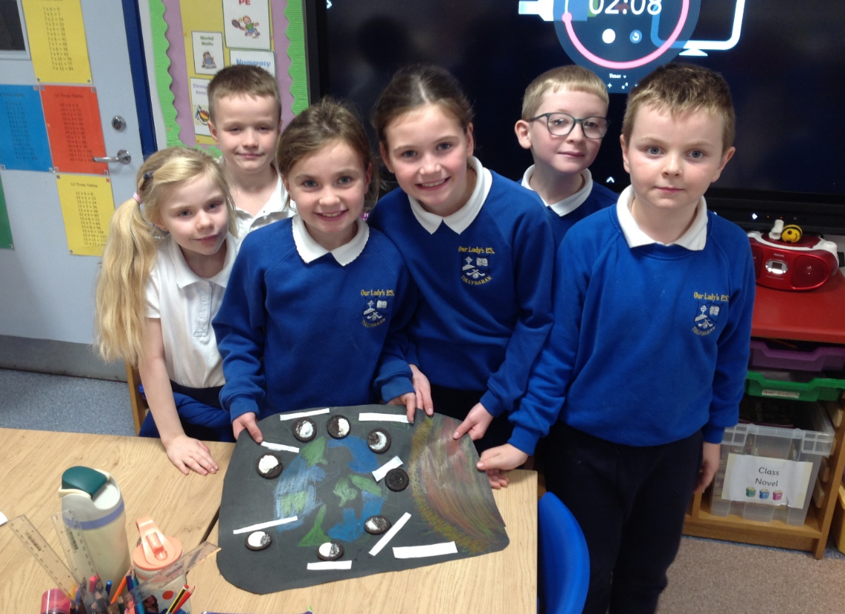

Pupil Attendance
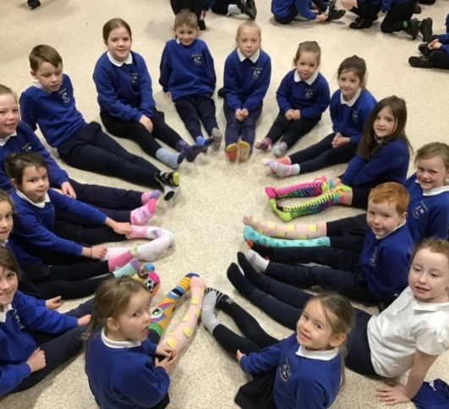
Parents are responsible for ensuring that their children attend school and arrive on time for lessons. We work with parents when necessary to improve attendance and punctuality. If attendance falls below 85% the Educational Welfare Service are informed. Parents should inform the school by phone or email on the first day of absence and submit a note explaining the absence when the child returns to school. Children with an attendance above 99% receive an award at the end of the school year.

Religious Education
Our Lady’s Primary School is a Catholic Maintained School; the Religious Education Programme follows the requirements of the Diocesan Religious Education committee. The ethos of the Catholic School permeates all aspects of school life and is delivered using the ‘Grow in Love’ series. Prayer is a regular part of the school day. Each school year begins and ends with a school Mass to which parents are invited. Classes celebrate assemblies throughout the year.
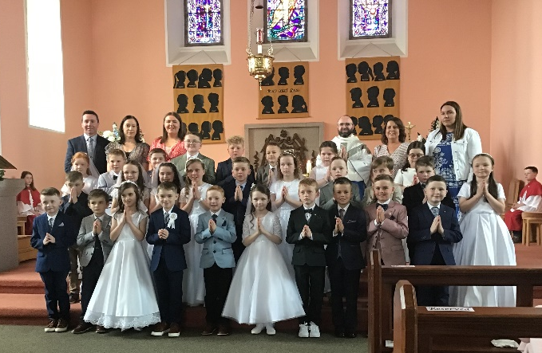
Children in Primary 4 will be prepared for First Confession and First Holy Communion and the pupils of Primary 7 will be prepared for the Sacrament of Confirmation.
Admission applications from families of all faiths and none are welcomed by the Board of Governors and special arrangements will be made for these children.

Equal Opportunities
We aim to promote an awareness of what we all have in common as children of a loving God. We believe that every child should have equal access to the curriculum, play and social development.
We expect every member of school to respect each other, whatever their race, gender, culture, religion, class, ability, or disability.
We encourage awareness and understanding of each other’s differences and will not accept verbal abuse of any kind, stereotyping, disrespect, or physical violence.
The school will consider the needs of both children with SEN and gifted children when allocating resources.
Effort will be made to provide maximum access to the curriculum for all children.

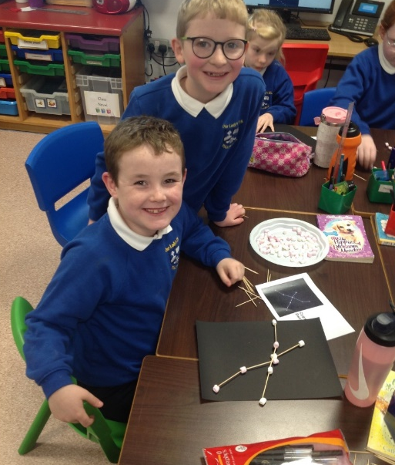

Homework
Our Lady’s Primary School values homework as a means of reinforcing work done, to research information unavailable in school, to involve parents in their children’s studies and in the development of good work habits. It is also important for children to have time for recreation and the development of private interests and hobbies, so we aim to ensure that homeworks are manageable for pupils.
The completion of Homework also helps pupils to prepare for the transition to post-primary school, where they will require self-management skills for managing their time and workload as they progress through school.

Extra-Curricular Activities
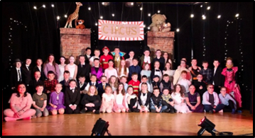
Our Lady’s Primary School has developed a wide variety of extra-curricular activities. It is the intention of the Board of Governors that this will be maintained and continued to be further developed. All pupils will be engaged in sport, music making and in both artistic and craft creations. There will also be the opportunity for the development of these interests in after school activities.

Eco Schools
We are an Eco-friendly school, achieving three green flags in recent years. Our Eco/School Council meets with the principal and relevant staff to ensure we encourage biodiversity and respect for our environment within the school grounds.

Breakfast, 123 & 3-5 Clubs
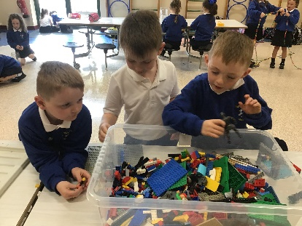
Our Lady’s Primary School has a well-established Breakfast club from 8-8.40 am. Children are supervised and receive a warm breakfast of: cereal, pancake, toast, juice or water for £2.50 per day. Our 123 Club operates from 2-3pm for P1-3 children who participate in a variety of enjoyable, interactive activities at a charge of £4 per day.
We also have a 3-5 Club which is available for all P1-P7 pupils at a charge of £4 per hour. Children are provided with the opportunity to complete some of their homework, receive a snack and enjoy some free time with their peers.

Charging and Remissions Policy
Education in Our Lady’s Primary school is provided free of charge for all lessons and activities connected with the child’s entitlement under the Education Reform Order.

The school will appeal to parents from time to time for voluntary contributions or donations, but it is stressed that no child will be disadvantaged in any way if parents choose not to or cannot afford to make a contribution.

The school may take part in optional extras which are not connected with the school’s formal curriculum, such as visits to the theatre. Charges will be made for these, but it is again stressed that failure to participate in these will not affect the child’s performance at school. Written parental consent will be required before a child participates in school trips. There is a code of conduct for all educational trips.

Outside tutors who are providing after school classes will charge for their services and these will be passed on to parents.

Drugs Education
The emphasis of our drugs education programme, as outlined in our Drugs Policy, is on the dangers involved in the misuse of tobacco, alcohol, and medicine. As our programme responds to need, we will include other substances when appropriate. This programme is delivered through Personal Development and Mutual Understanding, World Around Us and our Religious Education Programme.

Links with the Community
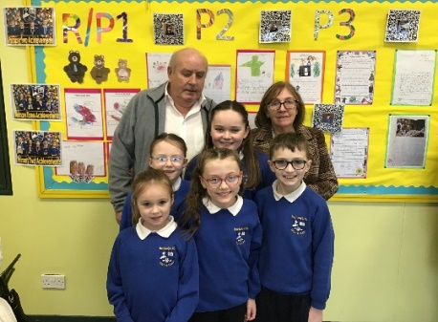
Our Lady’s Primary School is proud of its standing in the community which it serves. The school works closely with the Armagh parish and pupils from the school participate in Masses in the Church. The school has many sporting links, the strongest of these being with O’Connells GAC, Tullysaran. The club assists the school with coaching, hosting Cumann na mBunscol blitzes and other events. We use the Community Centre and are well supported by local businesses in the community. The school also has close links with local primary and post primary schools. Killylea Primary school is our partner school in Shared Education.

Handling Complaints Procedure
Our Lady’s Primary School takes complaints very seriously. We have the best interests of all our pupils and their families at the centre of all we do. In this regard, we encourage anyone with a concern to speak to us as soon as possible. If concerns are dealt with at an early stage, then they are more likely to be resolved and there is no unnecessary dissatisfaction. Open communication and regular engagement between the school, parents/guardians and other stakeholders is vital to the effective management of the school. Therefore, we would encourage you to bring your concerns to us and we will aim to resolve them. In the first instance contact should be made with the class teacher. If the matter remains unresolved then an appointment can be made to meet with the Principal.
Complaints Procedure – At a glance
Stage One
Write to the Principal
Stage Two
Write to the Chairperson of Board of Governors

If, following Stage Two you remain dissatisfied with the outcome of your complaint, you can refer the matter to the Office of the Northern Ireland Public Services Ombudsman (NIPSO).

This procedure applies for complaints/concerns in general, relating to all aspects of the school life. The summary policy is available to all parents from our school office and website.

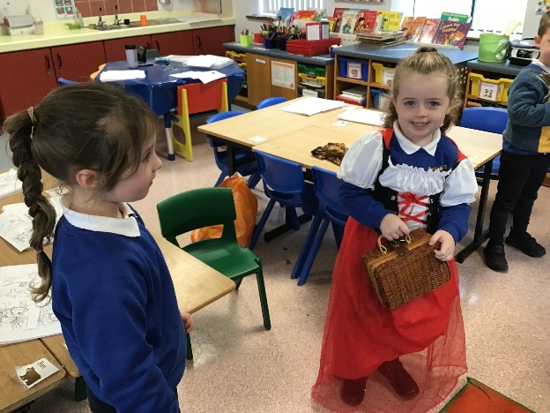
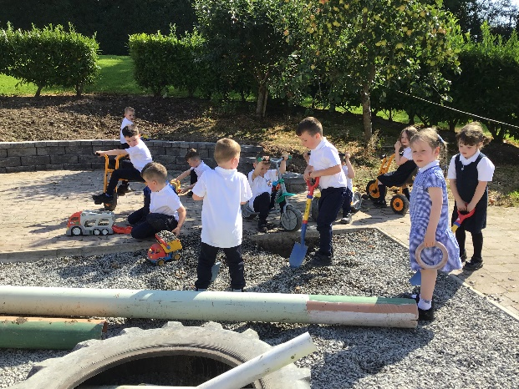

Data Protection
Our Lady’s Primary School requests information from parents regarding their children that may be personal or sometimes sensitive. The school seeks to comply with the relevant Data Protection legislation and ensures that all appropriate systems and procedures are put in place to safeguard this data. Parents will always be informed of the reason for the request for personal information and how the information is to be processed. At no time will the school provide parents’ information to third parties unless directly related to their educational provision.

Mid-Academic Year Changes
If there are any changes in the above information due to unforeseen circumstances during the school year parents/guardians will be informed of the nature of such a change.
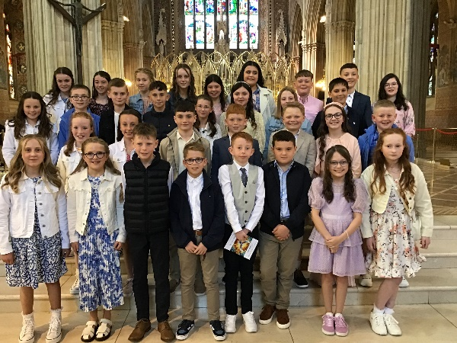

Please contact our school if you have any queries. If you are considering sending your child to our school, please scan the QR Code below to view our website and learn more about our school. If you would like to visit Our Lady’s, please contact the school office to arrange an appointment. Thank you.



2025/26 Classes
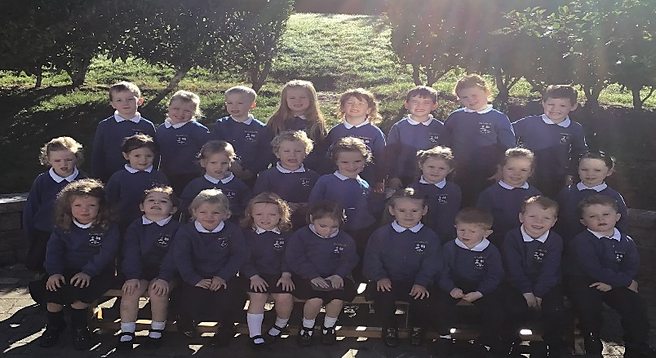

P1

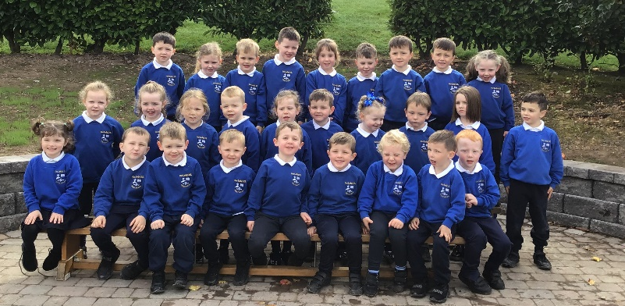
P2


P3/4
CH

P3/4
AMcC

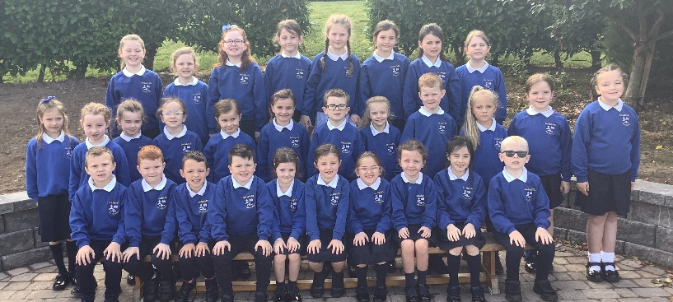

2025/26 Classes
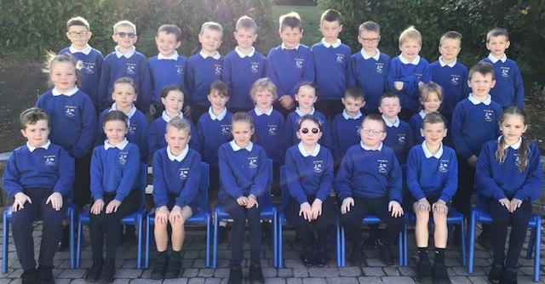

P5

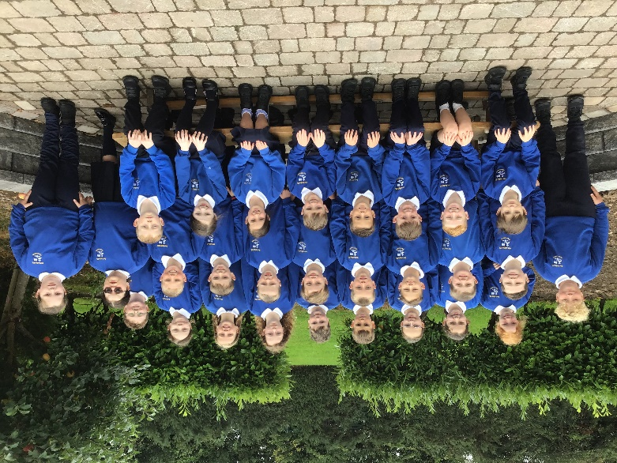

P6

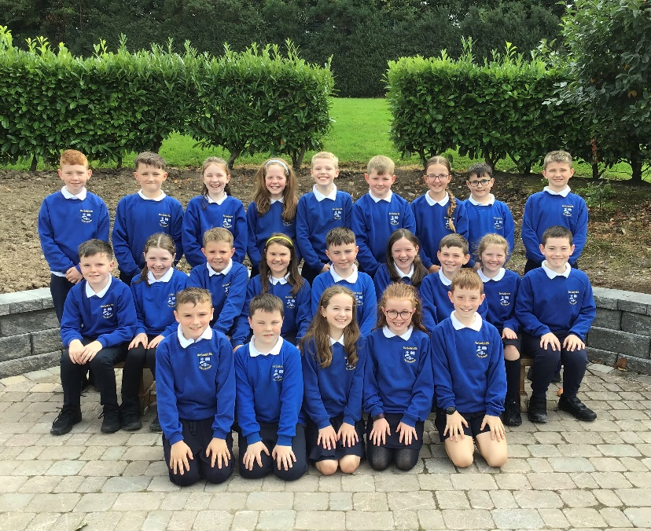

P7

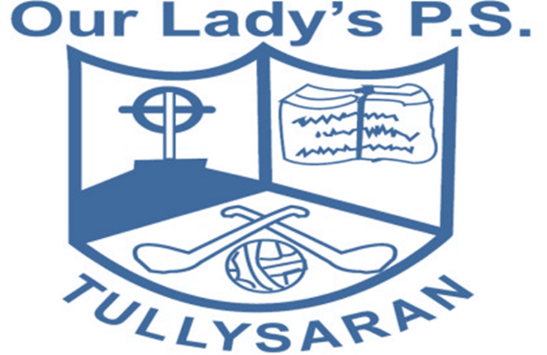

‘Learning through Friendship.’

Telephone – 02837548237
E-mail: info@ourladys.tullysaran.ni.sch.uk
Website: ourladyspstullysaran.com
Facebook: Our Lady’s Primary School, Tullysaran

